**VIVEKANAND EDUCATION SOCIETY’S**

**INSTITUTE OF TECHNOLOGY**

**Department of Computer Engineering**



Project Report on

# Portfolio Optimization and Risk Management Using Advanced Quantitative Models

In partial fulfillment of the Fourth Year (Semester–VIII), Bachelor of Engineering

(B.E.) Degree in Computer Engineering at the University of Mumbai Academic Year 2024-2025

**Submitted by**

KRISHNAM RAJA D17A-49

UZAIR SHAIKH D17A-56

DHIREN SIDHWANI D17A-60

**Project Mentor**

Prof. Mrs. Abha Tewari

(2024-25)

**VIVEKANAND EDUCATION SOCIETY’S INSTITUTE OF TECHNOLOGY**

**An Autonomous Institute Affiliated to University of Mumbai**

**Department of Computer Engineering**



**Certificate**

This is to certify that ***Krishnam Raja (49), Uzair Shaikh (56), Dhiren Sidhwani (60)*** of Fourth Year Computer Engineering studying under the University of Mumbai have satisfactorily completed the project on “***Portfolio Optimization and Risk Management Using Advanced Quantitative Models***” as a part of their coursework of PROJECT-II for Semester-VIII under the guidance of their mentor  ***Prof. Mrs. Abha Tewari*** in the year 2024-25 .

This project report entitled ***Portfolio Optimization and Risk Management Using Advanced Quantitative Models*** by s is to certify that ***Krishnam Raja, Uzair Shaikh, Dhiren Sidhwani***  is approved for the degree of **B.E. Computer Engineering.**

| Programme Outcomes | Grade |
| --- | --- |
| PO1,PO2,PO3,PO4,PO5,PO6,PO7,  PO8, PO9, PO10, PO11, PO12  PSO1, PSO2 |  |

Date:

Project Guide:

-----------------------------------------

**Project Report Approval**

**For**

**B. E (Computer Engineering)**

This project report entitled ***Portfolio Optimization and Risk Management Using Advanced Quantitative Models*** by ***Krishnam Raja, Uzair Shaikh, Dhiren Sidhwani*** is approved for the degree of **B.E. Computer Engineering.**

Internal Examiner

---------------------------------------------

External Examiner

---------------------------------------------

Head of the Department

-----------------------------------------------

Principal

-----------------------------------------------

Date:

Place

**Declaration**

We declare that this written submission represents our ideas in our own words and where others' ideas or words have been included, we have adequately cited and referenced the original sources. We also declare that we have adhered to all principles of academic honesty and integrity and have not misrepresented or fabricated or falsified any idea/data/fact/source in our submission. We understand that any violation of the above will be cause for disciplinary action by the Institute and can also evoke penal action from the sources which have thus not been properly cited or from whom proper permission has not been taken when needed.

| -----------------------------------------  Krishnam Raja (49) | -----------------------------------------  Uzair Shaikh (56) |
| --- | --- |
| -----------------------------------------  Dhiren Sidhwani (60) |  |

Date:

**ACKNOWLEDGEMENT**

We are thankful to our college Vivekanand Education Society’s Institute of Technology for considering our project and extending help at all stages needed during our work of collecting information regarding the project.

It gives us immense pleasure to express our deep and sincere gratitude to Assistant Professor **Mrs. Abha Tewari**  for her kind help and valuable advice during the development of project synopsis and for her guidance and suggestions.

We are deeply indebted to Head of the Computer Department **Dr.(Mrs.) Nupur Giri** and our Principal **Dr. (Mrs.) J.M. Nair ,** for giving us this valuable opportunity to do this project.

We express our hearty thanks to them for their assistance without which it would have been difficult in finishing this project synopsis and project review successfully.

We convey our deep sense of gratitude to all teaching and non-teaching staff for their constant encouragement, support and selfless help throughout the project work. It is great pleasure to acknowledge the help and suggestion, which we received from the Department of Computer Engineering.

We wish to express our profound thanks to all those who helped us in gathering information about the project. Our families too have provided moral support and encouragement at several times.

**Computer Engineering Department**

**COURSE OUTCOMES FOR B.E PROJECT**

Learners will be to,

| **Course Outcome** | **Description of the Course Outcome** |
| --- | --- |
| CO 1 | Able to apply the relevant engineering concepts, knowledge and skills towards the project. |
| CO2 | Able to identify, formulate and interpret the various relevant research papers and to determine the problem. |
| CO 3 | Able to apply the engineering concepts towards designing solutions for the problem. |
| CO 4 | Able to interpret the data and datasets to be utilized. |
| CO 5 | Able to create, select and apply appropriate technologies, techniques, resources and tools for the project. |
| CO 6 | Able to apply ethical, professional policies and principles towards societal, environmental, safety and cultural benefit. |
| CO 7 | Able to function effectively as an individual, and as a member of a team, allocating roles with clear lines of responsibility and accountability. |
| CO 8 | Able to write effective reports, design documents and make effective presentations. |
| CO 9 | Able to apply engineering and management principles to the project as a team member. |
| CO 10 | Able to apply the project domain knowledge to sharpen one’s competency. |
| CO 11 | Able to develop professional, presentational, balanced and structured approach towards project development. |
| CO 12 | Able to adopt skills, languages, environment and platforms for creating innovative solutions for the project. |

**Index**

| Chapter No. | Title | Page  No. |
| --- | --- | --- |
| **1** | **Introduction** | 2 |
| 1.1 | Introduction to the project | 2 |
| 1.2 | Motivation for the project | 3 |
| 1.3 | Problem Definition | 4 |
| 1.4 | Existing Systems | 5 |
| 1.5 | Lacuna of the Existing Systems | 5 |
| 1.6 | Relevance of the Project | 6 |
| **2** | **Literature Survey** | 8 |
| A | Brief overview of Literature Survey | 8 |
| 2.1 | Research Papers  a. Abstract of the research paper  b. Inference drawn from the paper | 8 |
| **3.** | **Requirement Gathering for the proposed System** | 16 |
| 3.1 | Introduction to Requirement Gathering | 16 |
| 3.2 | Functional Requirements | 16 |
| 3.3 | Non-Functional Requirements | 18 |
| 3.4 | Hardware, Software, Technology and tools utilised | 19 |
| 3.5 | Constraints | 21 |
| **4.** | **Proposed Design** | 23 |
| 4.1 | Block diagram of the system | 23 |
| 4.2 | Modular design of the system | 23 |

**VI**

| 4.3 | Project Scheduling &amp; Tracking using Timeline / Gantt Chart | 26 |
| --- | --- | --- |
| **5.** | **Implementation of the Proposed System** | 28 |
| 5.1 | Methodology employed for development | 28 |
| 5.2 | Algorithms and flowcharts for the respective modules developed | 28 |
| 5.3 | Datasets source and utilisation | 31 |
| **6.** | **Results and Discussions** | 32 |
| 6.1 | Screenshots of User Interface (UI) for the respective module | 32 |
| 6.2 | Performance Evaluation measures | 38 |
| 6.3 | Comparison of results with existing systems | 39 |
| 6.4 | Inference drawn | 40 |
| **7.** | **Conclusion** | 41 |
| 7.1 | Limitations | 41 |
| 7.2 | Conclusion | 42 |
| 7.3 | Future Scope | 43 |
|  | **References** | 44 |
|  | **Appendix** | 45 |
| **1** | **Paper I** | 45 |
| a | Paper I | 45 |
| b | Plagiarism Report of Paper I | 45 |
| c | Project review sheet | 46 |
| 2 | Competition Certificates | 47 |

**VII**

**List of Figures**

| Figure Number | Heading | Page no. |
| --- | --- | --- |
| 4.1 | Block Diagram | 23 |
| 4.2 | Modular Diagram | 23 |
| 4.3 | Flowchart | 25 |
| 4.4 | Gantt Chart | 27 |
| 5.1 | LSTM flowchart | 29 |
| 5.2 | ARIMA flowchart | 30 |
| 6.1 | Registration (1) | 32 |
| 6.2 | Registration (2) | 32 |
| 6.3 | MongoDB Database | 33 |
| 6.4 | Invalid user Sign in | 33 |
| 6.5 | Valid user Sign in | 34 |
| 6.6 | User Dashboard | 34 |
| 6.7 | Graph of selected stock (ICICI Bank) | 35 |
| 6.8 | Predictions | 35 |
| 6.9 | Latest news of selected stock | 36 |
| 6.10 | News Article | 36 |
| 6.11 | Suggestions | 37 |
| 6.12 | Sentiment Score | 37 |

**VIII**

**List of tables**

| Table Number | Heading | Page no. |
| --- | --- | --- |
| 1 | Schedule | 26 |
| 2 | Evaluation | 38 |
| 3 | Comparison of results | 39 |

**IX**

**Abstract**

In today’s complex financial markets, portfolio optimization and risk management have become paramount for investors aiming to balance returns and minimize risks. This project leverages advanced quantitative models, including LSTM (Long Short-Term Memory) and MPT to enhance portfolio management. These models not only factor in historical market data but also predict future price movements and potential risks, allowing for more adaptive and informed asset allocation decisions.

The use of LSTM networks, known for their ability to capture long-term dependencies in time-series data, provides a more nuanced analysis of asset trends and market fluctuation. Together, these models allow for dynamic portfolio adjustments, which are key in managing both volatility and market unpredictability.

**Chapter 1 : Introduction**

**1.1. Introduction to the project**

The financial markets are governed by a complex network of assets, each subject to various economic forces. In this environment, portfolio optimization plays a critical role in achieving a balance between risk and return. There are two primary types of risk: systematic (market-wide) and unsystematic (asset-specific). Systematic risk, such as inflation or political instability, affects the entire market and is unavoidable. Unsystematic risk, on the other hand, is specific to individual assets and can be mitigated through proper diversification. To maximize portfolio returns while minimizing risk, investors often rely on quantitative models. Traditional portfolio management approaches use techniques like mean-variance optimization to allocate assets, but these often lack the predictive power necessary to handle the complexity of today’s markets.

This project introduces a robust model for portfolio optimization by integrating machine learning techniques like LSTM. LSTMs are highly effective in capturing both short-term and long-term market trends from historical data. This combination allows for more accurate forecasting of asset behaviors and portfolio returns. By analyzing vast datasets and identifying patterns, these models help in creating a dynamically optimized portfolio that adjusts to market volatility and price fluctuations.

The advanced techniques employed in this project significantly improve the precision and effectiveness of portfolio management. This approach not only addresses systematic risk through diversification but also mitigates unsystematic risk by allocating assets based on data-driven predictions. The result is a framework that maximizes returns while keeping risk exposure within acceptable limits. Investors benefit from a more reliable and adaptive strategy, ensuring better performance under varying market conditions.

Timely and accurate portfolio optimization is crucial for effective financial planning and better investment outcomes. However, traditional methods of portfolio management often require labor-intensive and costly analysis, leading to potential delays in decision-making. Our framework addresses this challenge by harnessing the principles of Modern Portfolio Theory (MPT), which emphasizes the importance of diversification and the risk-return trade-off. By analyzing historical data and correlations among various assets, MPT enables the creation of an optimized portfolio that balances risk and expected return. The portfolio optimization process involves four key stages: Data Preprocessing, Risk Assessment, Asset Allocation, and Performance Evaluation. By applying these methodologies, our framework aims to significantly improve the efficiency and accuracy of portfolio management.

Traditional methods, while valuable, now face challenges in keeping pace with the increasing complexity and volatility of financial markets. Recognizing this, the focus of this project is to enhance the precision and adaptability of portfolio optimization using Modern Portfolio Theory. This initiative seeks to improve financial returns and risk management, maximizing the potential for successful investment strategies in an evolving market landscape.

**1.2. Motivation for the project**

The motivation behind our portfolio optimization framework extends beyond merely automating investment strategies for financial organizations. It encompasses several critical aspects of effective financial management and risk mitigation.

Firstly, the excessive costs and inefficiencies associated with traditional portfolio management methods are significant challenges. By utilizing Modern Portfolio Theory, our framework aims to provide accurate asset allocation and risk assessment, reducing the financial burden on investors while maintaining high standards of investment performance.

Secondly, the increasing volatility and complexity of financial markets have become pressing concerns for investors. Factors such as geopolitical events, economic fluctuations, and market sentiment necessitate the development of advanced optimization tools. Our framework seeks to provide timely insights into potential risks and opportunities, promoting proactive investment strategies and better financial outcomes.

Thirdly, the current fragmentation of financial data can hinder effective portfolio analysis and decision-making. Our framework aims to create a structured and easily accessible digital repository of investment data, streamlining the investment process and enabling comprehensive analysis and strategic planning.

In summary, the motivation behind our portfolio optimization framework lies in cost reduction, efficient financial management, proactive investment strategies, and organized data management—all of which are vital to advancing investment practices and promoting a holistic approach to portfolio optimization.

**1.3. Problem Definition**

The financial sector faces significant challenges in efficiently and effectively managing investment portfolios. Traditional methods often rely on manual analysis and outdated strategies, leading to inefficiencies and higher costs for investors. Additionally, the increasing volatility of financial markets underscores the urgent need for proactive portfolio management strategies. The fragmentation of financial data further complicates effective analysis and decision-making. To address these issues, our portfolio optimization framework aims to develop a systematic approach that utilizes Modern Portfolio Theory to enhance investment performance and promote equitable access to advanced financial management.

**Objectives:**

1. **Develop a comprehensive portfolio optimization framework** that automates asset allocation and risk assessment using Modern Portfolio Theory, ensuring a data-driven approach to investment decisions.
2. **Optimize cost-efficiency** by minimizing reliance on traditional management practices, thereby reducing fees and promoting accessibility to effective portfolio management strategies.
3. **Enhance accuracy and responsiveness** in portfolio optimization, enabling investors to adapt to market changes and make informed decisions in a timely manner.
4. **Create a structured digital repository** for storing and analyzing investment data, improving the efficiency of portfolio management and facilitating comprehensive market research.
5. **Contribute to the advancement of financial technologies**, aiming to alleviate the burden of market volatility on investors and encourage a proactive approach to portfolio management

**1.4 Existing Systems**

Several existing systems and platforms cater to stock market analysis and portfolio optimization. Popular tools like Zerodha’s Kite, Groww, and Upstox provide retail investors with real-time stock data, basic financial ratios, and performance tracking of portfolios. International platforms such as Yahoo Finance, Bloomberg, and TradingView offer advanced charting tools, fundamental analysis, news integration, and community insights. Additionally, robo-advisors like INDmoney and smallcase offer model portfolios based on specific investment themes and use automated rebalancing strategies. However, most of these platforms lack personalized predictive modeling (like LSTM or ARIMA), do not provide deep learning-based forecasting, and rarely offer KPI-driven recommendations specific to the Indian stock market. This leaves room for more intelligent, customizable, and analytics-rich systems like the one proposed in this project.

**1.5 Lacuna of the existing systems**

Existing portfolio optimization and stock prediction systems, especially in the Indian market, suffer from several limitations:

1. **Limited Access to Advanced Tools**: Most portfolio management tools available to retail investors are limited in terms of functionality and analytical capabilities. They lack access to the sophisticated machine learning models and financial algorithms used by institutional investors, making it difficult for individual investors to make data-driven decisions.
2. **Manual Data Processing**: Traditional systems often require manual analysis and data processing, which is time-consuming and prone to human error. These systems do not leverage the power of automation and real-time data processing that modern machine learning techniques offer.
3. **Inadequate Risk Management**: Many existing platforms do not provide adequate tools for risk assessment and management, leaving investors without a clear understanding of the potential risks associated with their portfolios. There is also a lack of scenario-based analysis that can simulate market conditions and assess portfolio performance under different circumstances.
4. **Fragmented Data Sources**: Current systems often rely on static datasets and do not integrate real-time stock prices, news, and market trends, which are critical for making timely investment decisions. This creates a lag in the availability of actionable insights.
5. **One-size-fits-all Recommendations**: Many platforms provide generic stock recommendations, which are not tailored to individual preferences or risk tolerance. This results in suboptimal investment strategies for users with different financial goals.

**1.6 Relevance of the Project**

The relevance of our portfolio optimization framework lies in its alignment with the evolving demands of today's financial landscape. As markets become increasingly volatile and interconnected, investors face heightened uncertainty regarding asset performance and risk exposure. Traditional methods often struggle to adapt to these rapid changes, resulting in missed opportunities and suboptimal returns. Our project leverages Modern Portfolio Theory to create a robust framework that allows investors to navigate complexities in the market more effectively. By providing a systematic approach to asset allocation and risk management, we aim to enhance financial decision-making and improve overall investment outcomes.

Furthermore, the need for cost-efficient investment solutions is more pressing than ever. As management fees and operational costs continue to rise, investors are seeking alternatives that deliver superior value without compromising quality. Our framework addresses this issue by minimizing reliance on manual analysis and providing an automated, data-driven solution that reduces costs associated with traditional portfolio management.

In addition to improving financial performance, our project is relevant in the context of promoting financial literacy and empowering investors. By integrating advanced quantitative models and providing clear insights into portfolio performance, we aim to demystify complex investment strategies. This initiative seeks to equip investors with the knowledge and tools necessary to make informed decisions, fostering a more financially savvy population. By making sophisticated portfolio optimization techniques accessible to all, we encourage a proactive approach to investment management.

Lastly, our portfolio optimization framework aligns with the broader trends of technological innovation and data analytics in finance. As the industry increasingly embraces technology, our project contributes to the ongoing transformation of financial services. By utilizing modern methodologies and harnessing the power of data, we aim to establish a forward-thinking approach that not only addresses current challenges but also anticipates future developments in the financial sector. This relevance extends beyond immediate financial benefits, as we contribute to the evolution of investment practices in an increasingly digital world.

### Chapter 2: Literature Survey

**A. Brief Overview of Literature Survey**

A literature survey was conducted to understand the existing methodologies and tools used for stock market prediction and portfolio optimization. Several studies explored the effectiveness of traditional statistical models like ARIMA and machine learning techniques such as Support Vector Machines and Random Forests for stock price forecasting. Recent research highlights the increasing adoption of deep learning models, particularly Long Short-Term Memory (LSTM) networks, due to their ability to capture temporal dependencies in time-series financial data. Literature on portfolio optimization emphasizes the use of Modern Portfolio Theory (MPT), Mean-Variance Optimization, and Sharpe Ratio-based strategies to balance risk and return. While many systems integrate either forecasting or portfolio management independently, the literature reveals a gap in unified platforms that combine advanced predictive analytics with intelligent portfolio rebalancing—especially tailored to the Indian stock market. This project aims to bridge that gap using a hybrid approach based on insights from these studies.

**2.1 Research Papers Referred**

1. [**Marin Lolic, “Practical Improvements to Mean-Variance Optimization for Multi-Asset Class Portfolios”, J. Risk Financial Manag. 2024, 17(5), 183.**](https://www.mdpi.com/1911-8074/17/5/183)

**Abstract:**  In the more than 70 years since Markowitz introduced mean-variance optimization for portfolio construction, academics and practitioners have documented numerous weaknesses in the approach. In this paper, we propose two easily understandable improvements to mean-variance optimization in the context of multi-asset class portfolios, each of which provides less extreme and more stable portfolio weights. The first method sacrifices a small amount of expected optimality for reduced weight concentration, while the second method randomly resamples the available assets. Additionally, we develop a process for testing the performance of portfolio construction approaches on simulated data assuming variable degrees of forecasting skill. Finally, we show that the improved methods achieve better out-of-sample risk-adjusted returns than standard mean variance optimization for realistic investor skill levels.

**Inference:** The research paper "Practical Improvements to Mean-Variance Optimization for Multi-Asset Class Portfolios" by Marin Lolic introduces two practical and intuitive enhancements to traditional Mean-Variance Optimization (MVO), addressing its well-known issues such as instability and extreme portfolio allocations. The first method, "Near-Optimality," minimizes portfolio concentration while maintaining utility close to the optimal level. The second, "Resampling Assets," averages optimized portfolios built from random subsets of assets to reduce overreliance on specific ones. Both methods are tested using simulated return data under varying levels of forecasting skill and consistently outperform standard MVO in out-of-sample Sharpe ratios for most realistic scenarios. These improvements lead to more stable, diversified portfolios with reduced sensitivity to estimation errors, offering a balance between simplicity, effectiveness, and real-world applicability for portfolio managers.

1. [**Yu Ma, Rui Mao, Qika Lin, Peng Wu, Erik Cambria, “Quantitative stock portfolio optimization by multi-task learning risk and return”, Information Fusion Volume 104, April 2024, 102165**](https://www.sciencedirect.com/science/article/abs/pii/S1566253523004815?via%3Dihub)

**Abstract:**  Selecting profitable stocks for investments is a challenging task. Recent research has made significant progress on stock ranking prediction to select top-ranked stocks for portfolio optimization. However, the stocks are only ranked by predicted stock return, ignoring the stock price volatility risk — a critical aspect for stock selection and investments. Moreover, they preliminarily attempted to capture the effects of related stocks from a singular relation, disregarding the rich information regarding multiple spillover effects from related stocks and the distinctions in effects among various relations. Thus, we propose a risk and return multi task learning model with a heterogeneous graph attention network (HGA-MT) to predict stock ranking for portfolio optimization. First, to aggregate the multiple spillover effects of related stocks, we introduce graph convolutional networks to fuse the effects of related stocks in each relation and design an attention network to allocate varying weights to different types of relationships. Second, we use a multi-task learning paradigm to learn stock return and volatility risks jointly. The stock ranking results are calculated by simultaneously considering the risk and return. Thus, Top-𝐾 ranked stocks are recommended in the portfolio for the next trading day to achieve higher and more stable profits. Extensive experiments prove that HGA-MT outperforms previous state-of-the-art methods in stock ranking and backtesting trading evaluation tasks.

**Inference:** The research paper titled "Quantitative Stock Portfolio Optimization by Multi-task Learning Risk and Return" proposes a novel deep learning model called HGA-MT, which integrates heterogeneous graph attention mechanisms and multi-task learning to enhance stock portfolio optimization. Unlike traditional models that prioritize stock return alone, this approach jointly learns both stock return and volatility risk to generate more robust and stable stock rankings. By leveraging multi-source information—including quantitative financial indicators, sentiment-based news data, and diverse stock relations such as supply chain, shareholding, and industry competition—the model effectively captures multiple spillover effects from related stocks. Experimental results on Chinese stock market data show that HGA-MT significantly outperforms existing state-of-the-art models in both ranking precision and financial returns, delivering improved investment performance with reduced risk.

1. [**Preeti Paranjape-Voditel, Umesh Deshpande, A stock market portfolio recommender system based on association rule mining, Applied Soft Computing, Volume 13, Issue 2, 2013**](https://www.sciencedirect.com/science/article/abs/pii/S1568494612004322?via%3Dihub)

**Abstract:** We propose a stock market portfolio recommender system based on association rule mining (ARM) that analyzes stock data and suggests a ranked basket of stocks. The objective of this recommender system is to support stock market traders, individual investors and fund managers in their decisions by suggesting investment in a group of equity stocks when strong evidence of possible profit from these transactions is available. Our system is different compared to existing systems because it finds the correlation between stocks and recommends a portfolio. Existing techniques recommend buying or selling a single stock and do not recommend a portfolio. We have used the support confidence framework for generating association rules. The use of traditional ARM is infeasible because the number of association rules is exponential and finding relevant rules from this set is difficult. Therefore ARM techniques have been augmented with domain specific techniques like formation of thematical sectors, use of cross-sector and intra-sector rules to overcome the disadvantages of traditional ARM. We have implemented novel methods like using fuzzy logic and the concept of time lags to generate datasets from actual data of stock prices. Thorough experimentation has been performed on a variety of datasets like the BSE-30 sensitive Index, the S&P CNX Nifty or NSE-50, S&P CNX-100 and DOW-30 Industrial Average. We have compared the returns of our recommender system with the returns obtained from the top-5 mutual funds in India. The results of our system have surpassed the results from the mutual funds for all the datasets. Our approach demonstrates the application of soft computing techniques like ARM and fuzzy classifi cation in the design of recommender systems.

**Inference:** The research paper titled "A Stock Market Portfolio Recommender System Based on Association Rule Mining" proposes a novel system that suggests optimal stock portfolios rather than individual stock picks, using association rule mining (ARM), fuzzy logic, and time-lagged datasets. Unlike traditional approaches focused on technical or fundamental analysis of single stocks, this system identifies relationships among stocks across and within sectors, generating portfolio recommendations based on historical price movements. The methodology incorporates fuzzy classification to address threshold boundaries in price changes and introduces time-lagged datasets to capture delayed market trends. The system also includes mechanisms for periodic portfolio rebalancing to replace underperforming stocks. Tested on datasets like BSE-30, NSE-50, CNX-100, and DOW-30, the proposed system consistently outperforms top mutual funds in terms of ROI and precision, demonstrating its robustness, adaptability, and effectiveness in practical stock investment scenarios.

1. [**Jie Zou, Jiashu Lou, Baohua Wang, Sixue Liu, A novel Deep Reinforcement Learning based automated stock trading system using cascaded LSTM networks, Expert Systems with Applications, Volume 242, 2024**](https://www.sciencedirect.com/science/article/abs/pii/S0957417423033031?via%3Dihub)

**Abstract:** Deep Reinforcement Learning (DRL) algorithms have been increasingly used to construct stock trading strategies, but they often face performance challenges when applied to financial data with low signal-to-noise ratios and unevenness, as these methods were originally designed for the gaming community. To address this issue, we propose a DRL-based stock trading system that leverages Cascaded Long Short-Term Memory (CLSTM-PPO Model) to capture the hidden information in the daily stock data. Our model adopts a cascaded structure with two stages of carefully designed deep LSTM networks: it uses one LSTM to extract the time-series features from a sequence of daily stock data in the first stage, and then the features extracted are fed to the agent in the reinforcement learning algorithm for training, while the actor and the critic in the agent also use a LSTM network. We conduct experiments on stock market datasets from four major indices: the Dow Jones Industrial index (DJI) in the US, the Shanghai Stock Exchange 50 (SSE50) in China, S&P BSE Sensex Index (SENSEX) in India, and the Financial Times Stock Exchange 100 (FTSE100) in the UK. We compare our model with several benchmark models, including: (i) a model based on a buy-and-hold strategy; (ii) a Proximal Policy Optimization (PPO) model with Multilayer Perceptron (MLP) policy; (iii) some up-to-date models like the MLP model, LSTM model, Light Gradient Boosting Machine (LGBM) model, and histogram based gradient boosting model; and (iv) an ensemble strategy model. The experimental results show that our model outperforms the baseline models in several key metrics, such as cumulative returns, maximum earning rate, and average profitability per trade. The improvements range from 5% to 52%, depending on the metric and the stock index. This indicates that our proposed method is a promising way to build an automated stock trading system.

**Inference:** The research paper titled "A Novel Deep Reinforcement Learning Based Automated Stock Trading System Using Cascaded LSTM Networks" introduces a deep reinforcement learning (DRL) system—CLSTM-PPO—that enhances automated stock trading performance by leveraging a cascaded Long Short-Term Memory (LSTM) architecture. The system integrates an LSTM-based feature extractor with a Proximal Policy Optimization (PPO) agent to model stock trading as a Markov Decision Process (MDP), enabling the system to capture complex temporal dependencies and hidden patterns in noisy financial time-series data. Extensive experiments across diverse stock markets (US, China, India, and the UK) demonstrate that the proposed model outperforms traditional models, recurrent PPOs, and ensemble strategies in key metrics such as cumulative returns, Sharpe ratio, and profitability per trade. Notably, the system achieved up to 222.91% cumulative returns in the Chinese market, highlighting its ability to identify profitable opportunities in volatile environments. This work underscores the effectiveness of combining LSTM with DRL for robust, adaptive, and high-performing stock trading systems.

1. [**Zaharaddeen Karami Lawal; Hayati Yassin; Rufai Yusuf Zakari”Stock Market Prediction using Supervised Machine Learning Techniques: An Overview”2020 IEEE Asia-Pacific Conference on Computer Science and Data Engineering (CSDE), 2020**](https://sci-hub.se/https://ieeexplore.ieee.org/document/9411609)

**Abstract:** Stock price prediction is one of the most extensively studied and challenging glitches, which is acting so many academicians and industries experts from many fields comprising of economics, and business, arithmetic, and computational science. Predicting the stock market is not a simple task, mainly as a magnitude of the close to random-walk behavior of a stock time series. Millions of people across the globe are investing in stock market daily. A good stock price prediction model will help investors, management and decision makers in making correct and effective decisions. In this paper, we review studies on supervised machine learning models in stock market predictions. The study discussed how supervised machine learning techniques are applied to improve accuracy of stock market predictions. Support Vector Machine (SVM) was found to be the most frequently used technique for stock price prediction due to its good performance and accuracy. Other techniques like Artificial Neural Network (ANN), K-Nearest Neighbor (KNN), Naïve Bayes, Random Forest, Linear Regression and Support Vector Regression (SVR) also showed a promising prediction result.

**Inference:** The research paper titled "Stock Market Prediction using Supervised Machine Learning Techniques: An Overview" presents a comprehensive literature review on the use of supervised machine learning (ML) algorithms for predicting stock market trends. Through a systematic review of 38 studies, it evaluates various classification and regression models such as Support Vector Machines (SVM), Artificial Neural Networks (ANN), K-Nearest Neighbors (KNN), Random Forests, and Linear/Logistic Regression. The study finds that classification techniques are more commonly used than regression techniques, with SVM being the most frequently applied due to its robust accuracy and performance. It also highlights that the effectiveness of prediction models varies depending on data size and type, and notes limitations like overfitting in ANN, sensitivity to outliers in SVM, and training complexity in RNNs. The paper emphasizes the need for future research to address these challenges and improve model robustness, especially in handling noise, parameter optimization, and adaptability to dynamic market behavior.

1. [**AmirMohammad Larni-Fooeik,Seyed Jafar Sadjadi,Emran Mohammadi , “Stochastic portfolio optimization: A regret-based approach on volatility risk measures: An empirical evidence from The New York stock market”, April 22, 2024**](https://journals.plos.org/plosone/article?id=10.1371/journal.pone.0299699)

**Abstract:**  Portfolio optimization involves finding the ideal combination of securities and shares to reduce risk and increase profit in an investment. To assess the impact of risk in portfolio optimization, we utilize a significant volatility risk measure series. Behavioral finance biases play a critical role in portfolio optimization and the efficient allocation of stocks. Regret, within the realm of behavioral finance, is the feeling of remorse that causes hesitation in making significant decisions and avoiding actions that could lead to poor investment choices. This behavior often leads investors to hold onto losing investments for extended periods, refusing to acknowledge mistakes and accept losses. Ironically, by evading regret, investors may miss out on potential opportunities. in this paper, our purpose is to compare investment scenarios in the decision-making process and calculate the amount of regret obtained in each scenario. To accomplish this, we consider volatility risk metrics and utilize stochastic optimization to identify the most suitable scenario that not only maximizes yield in the investment portfolio and minimizes risk, but also minimizes resulting regret. To convert each multi-objective model into a single objective, we employ the augmented epsilon constraint (AEC) method to establish the Pareto efficiency frontier. As a means of validating the solution of this method, we analyze data spanning 20, 50, and 100 weeks from 150 selected stocks in the New York market based on fundamental analysis. The results show that the selection of the mad risk measure in the time horizon of 100 weeks with a regret rate of 0.104 is the most appropriate research scenario. this article recommended that investors diversify their portfolios by investing in a variety of assets. This can help reduce risk and increase overall returns and improve financial literacy among investors.

**Inference:** The research paper titled "Stochastic Portfolio Optimization: A Regret-Based Approach on Volatility Risk Measures – An Empirical Evidence from The New York Stock Market" presents a novel model that integrates behavioral finance concepts—particularly regret—into portfolio optimization. By employing stochastic programming and the Augmented Epsilon Constraint (AEC) method, the model evaluates three volatility-based risk measures (Semi-Variance, Mean Absolute Deviation, and Semi Absolute Deviation) across multiple investment horizons (20, 50, and 100 weeks). Using historical data from 150 NYSE stocks selected via fundamental analysis, the model identifies the optimal stock allocations that balance risk, return, and regret. The study reveals that a 100-week investment horizon using the MAD risk measure yields the lowest regret value (0.104), making it the most robust scenario. The findings emphasize that minimizing regret can lead to more informed investment decisions and higher returns, and the paper recommends scenario-based portfolio optimization as a practical tool for both investors and policymakers.

1. [**David Ajiga, Rhoda adura Adeleye, Tula Sunday Tubokirifuruar, Binaebi Bello, Onyeka, Franca Asuzu, Oluwaseyi Rita Owolabi, ” MACHINE LEARNING FOR STOCK MARKET FORECASTING: A REVIEW OF MODELS AND ACCURACY”, Finance &amp; Accounting Research Journal, Volume 6, Issue 2, February 2024**](https://www.researchgate.net/publication/380289212_MACHINE_LEARNING_FOR_STOCK_MARKET_FORECASTING_A_REVIEW_OF_MODELS_AND_ACCURACY)

**Abstract:** As financial markets become increasingly complex and dynamic, the application of machine learning (ML) techniques for stock market forecasting has garnered significant attention. This paper presents a comprehensive review of various ML models employed in the realm of stock market forecasting, focusing on their methodologies and the accuracy achieved in predicting market trends. The review begins by examining traditional time-series models such as autoregressive integrated moving average (ARIMA) and moving average convergence divergence (MACD) and their limitations in capturing the intricate patterns present in financial data. Subsequently, the discussion transitions to more advanced ML models, including support vector machines (SVM), artificial neural networks (ANN), and ensemble methods like random forests and gradient boosting. Each model's strengths and weaknesses are scrutinized in the context of stock market forecasting. The paper explores the pivotal role of feature selection and engineering in enhancing the predictive power of ML models. Feature sets encompassing financial indicators, macroeconomic variables, sentiment analysis from news articles, and social media data are analyzed for their impact on forecasting accuracy. Additionally, the incorporation of technical indicators and alternative data sources is explored as potential avenues to improve model robustness. A critical aspect of this review is the assessment of accuracy in predicting stock market movements. The evaluation is conducted through a comparative analysis of model performance metrics, including Mean Absolute Error (MAE), Mean Squared Error (MSE), and accuracy rates. The study also addresses the challenge of model overfitting and proposes strategies to mitigate this issue for more reliable predictions. This review provides a nuanced understanding of the landscape of ML models for stock market forecasting, highlighting the diverse approaches, challenges, and opportunities in the quest for improved accuracy. It contributes valuable insights for researchers, practitioners, and investors seeking to leverage the potential of ML in navigating the complexities of financial markets.

**Inference:** The research paper titled "Machine Learning for Stock Market Forecasting: A Review of Models and Accuracy" offers a detailed analysis of various traditional and machine learning (ML) approaches used for predicting stock market trends. It critically examines time-series models like ARIMA and MACD, as well as advanced ML techniques such as Support Vector Machines (SVM), Artificial Neural Networks (ANN), ensemble methods, and deep learning models. The study emphasizes the importance of feature selection and engineering, highlighting the role of diverse data inputs including financial indicators, macroeconomic variables, and sentiment data from news and social media. It also explores evaluation metrics like MAE, MSE, and accuracy, and addresses overfitting challenges and mitigation strategies. The paper concludes by advocating for the integration of hybrid models, alternative data sources, and interpretability to improve prediction reliability and guide future research, ultimately supporting investors and financial institutions in making informed decisions in volatile market conditions.

1. [**Research on Optimization Strategy of Quantitative Investment Scheme Based on Black-Litterman Model Jinhui Zhang* , Lanlan Shi, Wei Xu**](https://francis-press.com/uploads/papers/3sFXSwHmglRb1BhSQ5ObXItQuFXhQPairPdApWOQ.pdf)

**Abstract:** In today's trading market, for every investor, they want to obtain a higher rate of return within their own controllable risks. And how to obtain a maximum yield is undoubtedly a complex and difficult challenge. In order to help investors obtain a higher return in gold and bitcoin investment, we have integrated XGBoost, ESN, Black-Litterman and other models to establish a more optimized quantitative investment plan. Task 1: For the model, first use the optimized XGBoost-ESN model to predict the prices of gold and Bitcoin on the second day, and then use the Black-Litterman model to help investors make more accurate quantitative investments. From the initial $1,000 to the final $20,278.14, the annualized rate of return: 82.56%. Task 2: In order to predict the accuracy of the price, we use two different price prediction methods for prediction. The weights of the two are determined by the least squares method, and the optimized model is obtained. And in order to understand that our investment cycle is the optimal solution, we used different trading cycles of 5 days, 15 days, and 30 days for gold and Bitcoin to conduct a single-variable comparison test, and obtained different optimal transactions between the two cycle. Task 3: We conduct a dynamic analysis of transaction costs, and determine the optimal transaction cost range for gold and Bitcoin by understanding different transaction costs. Task 4: Since different investors have different risk acceptance levels, we have added var risk prediction content. In order to reduce the loss of income, we set a profit and loss line to ensure the safety of funds. Finally, we discuss the problems that may arise in the process of practical application of the model, and use the validity test to verify the validity of the established model. In addition, we provide a reasonable evaluation of the strengths and weaknesses of the model.

**Inference:** The research paper titled "Research on Optimization Strategy of Quantitative Investment Scheme Based on Black-Litterman Model" proposes a comprehensive framework for improving investment strategies in gold and Bitcoin using a hybrid of machine learning and financial modeling. By integrating the XGBoost-ESN predictive model with the Black-Litterman asset allocation model, the authors enhance the accuracy of price forecasts and portfolio optimization under varying risk preferences. The model achieved an impressive annualized return of 82.56% over five years from a $1,000 initial investment, reflecting its practical effectiveness. It also incorporates a Value-at-Risk (VAR) based historical simulation to manage risk, evaluates sensitivity to transaction costs, and tailors trading strategies to investor risk tolerance. The study concludes that short-term trading suits Bitcoin due to its volatility, while gold benefits from longer-term strategies. Overall, the paper demonstrates that combining advanced machine learning techniques with traditional financial models yields robust, adaptable, and high-return investment strategies.

**Chapter 3: Requirement Gathering for the Proposed System**

In any software project, gathering and specifying requirements is crucial to ensure that the proposed system aligns with user needs, project goals, and industry standards. Requirements define what the system should accomplish and how it should function. For the project titled **"Portfolio Optimization and Risk Management Using Advanced Quantitative Models"** the requirements analysis involves understanding functional and non-functional needs, technical constraints, and available resources. The method for gathering these requirements includes stakeholder interviews, market research, reviewing existing systems, and exploring relevant technologies.

The requirements for the project titled "**Portfolio Optimization and Risk Management Using Advanced Quantitative Models** " comprises of :-

**3.1. Introduction to Requirement Gathering:**

The Requirement Gathering is a process of requirements discovery or generating list of requirements or collecting as many requirements as possible by end users. It is also called as requirements elicitation or requirement capture.

The requirements gathering process consists of six steps :

● Identify the relevant stakeholders

● Establish project goals and objectives

● Elicit requirements from stakeholders

● Document the requirements

● Confirm the requirements

● Prioritise the requirements

**3.2. Functional Requirements:**

Functional requirements define the core functions and features that the system must support to achieve its objectives. These requirements outline **what the system should do** in terms of operations, inputs, outputs, and interactions.

**Functional Requirements for the Proposed System**:

1. **User Authentication**: The system should allow users to sign up, log in, and manage their accounts. The authentication process should be secure, supporting username/password combinations and encryption protocols.
   * **Justification**: Secure access is essential to protect sensitive financial data and ensure only authorized users can interact with the system.
2. **Stock Price Prediction**: The system should use machine learning models like LSTM and ARIMA to predict stock prices based on historical data.
   * **Justification**: Accurate stock price predictions are vital for portfolio optimization, helping users make informed investment decisions.
3. **Portfolio Optimization**: The system should apply Modern Portfolio Theory (MPT) to suggest optimal asset allocation that maximizes returns while minimizing risk.
   * **Justification**: Portfolio optimization is the key function of the system, aimed at helping users achieve the best balance between risk and return.
4. **Real-Time Data Integration**: The system should fetch live stock market data using APIs (like yFinance) and integrate it with the prediction models. Additionally, it should collect real-time financial news using NewsAPI.
   * **Justification**: Real-time data ensures that the predictions and recommendations are relevant to current market conditions, providing users with timely insights.
5. **Risk Assessment**: The system should perform risk analysis using techniques like Monte Carlo simulations and provide users with insights into the volatility and risk levels of their portfolios.
   * **Justification**: Proper risk management is crucial in financial decision-making, allowing users to understand and mitigate potential losses.
6. **Personalized Recommendations**: The system should analyze user preferences (risk tolerance, investment goals) and provide tailored stock recommendations.
   * **Justification**: Personalized investment suggestions help users navigate their unique financial situations and objectives, making the system more user-centric.

**3.3.Non-Functional Requirements:**

Non-functional requirements define the quality attributes, performance, and constraints the system must adhere to. They impact the overall user experience, scalability, and security of the platform.

**Non-Functional Requirements for the Proposed System**:

1. **Performance**: The system should be able to handle multiple users simultaneously without degradation in response time, ensuring quick access to data and predictions.
   * **Justification**: High performance is essential to provide real-time data analysis, which is crucial for time-sensitive financial decisions.
2. **Scalability**: The system must be scalable to support an increasing number of users and transactions as the platform grows.
   * **Justification**: A scalable system can accommodate more users without requiring a complete overhaul of the architecture, ensuring future growth.
3. **Security**: The platform should implement strong security measures, including encryption, secure API communication, and user data protection.
   * **Justification**: Given that financial data is highly sensitive, robust security protocols are essential to prevent data breaches and ensure user trust.
4. **Usability**: The interface should be user-friendly and intuitive, allowing users of varying financial knowledge to navigate and use the system easily.
   * **Justification**: A simple and intuitive interface improves user experience, making the platform accessible to retail and professional investors alike.
5. **Availability**: The system should be available 24/7 to accommodate users from different time zones and ensure that real-time data access is uninterrupted.
   * **Justification**: Continuous availability is critical, especially for a system that relies on real-time data updates and supports global users.

**3.4.Hardware, Software, Technology and Tools Utilised:**

The system will require specific hardware and software components for development, deployment, and use.

**Hardware Requirements**:

1. **Server Infrastructure**: High-performance cloud-based servers (AWS, Azure, or GCP) for data storage, API communication, and model computation.
   * **Justification**: Robust cloud infrastructure is essential for handling large-scale data and supporting real-time processing.
2. **User Devices**: Users can access the system through web browsers, requiring basic hardware such as personal computers or mobile devices.
   * **Justification**: The system should be accessible from any standard device to maximize user reach.

**Software Requirements**:

1. **Machine Learning Libraries**: TensorFlow, Keras, or PyTorch for building and deploying LSTM and ARIMA models.
   * **Justification**: These libraries are essential for training and implementing machine learning models efficiently.
2. **Database Management**: MongoDB or MySQL for storing user data, predictions, and financial information.
   * **Justification**: Efficient database management is crucial for handling user profiles, financial data, and historical stock prices.
3. **Web Framework**: Streamlit or Flask for creating the front-end interface of the platform.
   * **Justification**: A user-friendly web framework simplifies deployment and ensures a seamless user experience.

**Techniques utilized till date for the proposed system**

**Time-Series Forecasting**: LSTM and ARIMA models have been used for predicting stock prices.

* **Justification**: Time-series forecasting techniques help in capturing patterns in stock data, essential for making accurate predictions.

**Monte Carlo Simulations**: This technique is used to assess risk by simulating different market scenarios.

* **Justification**: Monte Carlo simulations are widely accepted in finance for evaluating potential portfolio outcomes under varying conditions.

**Modern Portfolio Theory (MPT)**: MPT is applied for optimizing asset allocation to maximize returns while minimizing risk.

* **Justification**: MPT is a foundational method in portfolio management, ensuring efficient risk-return optimization.

**Tools utilized till date for the proposed system**

**APIs (yFinance, NewsAPI)**: Used for retrieving real-time stock prices and financial news.

* **Justification**: APIs are essential for integrating up-to-date data directly into the system.

**Streamlit**: A framework for building the user interface of the platform.

* **Justification**: Streamlit simplifies the creation of interactive and data-driven web applications, making it an ideal choice for this project.

**TensorFlow/Keras**: For building and training machine learning models (LSTM, ARIMA).

* **Justification**: These libraries provide the necessary tools for implementing complex deep learning models in an efficient manner.

**Algorithms utilized in the existing systems**

**LSTM (Long Short-Term Memory)**: Used for time-series predictions in financial markets.

* **Justification**: LSTM is widely used in stock price forecasting due to its ability to capture long-term dependencies in time-series data.

**ARIMA (AutoRegressive Integrated Moving Average)**: Used for short-term stock price predictions.

* **Justification**: ARIMA models are effective in capturing trends and seasonality in financial data, making them suitable for market forecasting.

**Monte Carlo Simulation**: For risk assessment in portfolio management.

* **Justification**: Monte Carlo simulation provides a probabilistic approach to understanding portfolio risks, making it a valuable tool in investment planning.

**3.5. Constraints:**

Constraints refer to limitations or restrictions on the system, including regulatory, technical, or financial aspects.

**Constraints for the Proposed System**:

1. **Data Availability**: The system relies on third-party APIs like yFinance and NewsAPI for stock data and news. Any downtime or rate limits of these services can affect system functionality.
   * **Justification**: External data sources are not under direct control, so the system must handle API limits and potential unavailability effectively.
2. **Market Regulations**: Financial tools and platforms need to comply with regional laws and regulations related to data privacy, investment advice, and user consent.
   * **Justification**: Adherence to financial regulations ensures legal compliance and avoids penalties.
3. **Computational Resources**: Machine learning models like LSTM require significant computational power for training and prediction, potentially leading to higher infrastructure costs.
   * **Justification**: The project must balance resource availability with performance, ensuring that computations are optimized to reduce operational costs.

**Chapter 4: Proposed Design**

**4.1. Block Diagram of the proposed system:**

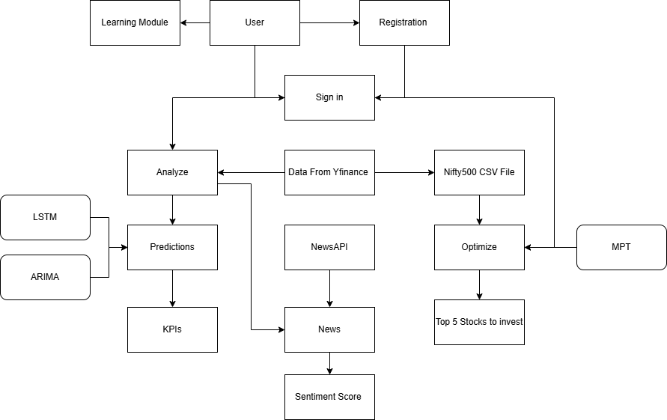

**Fig. 4.1 Block Diagram**

**4.2. Modular diagram of the system:**

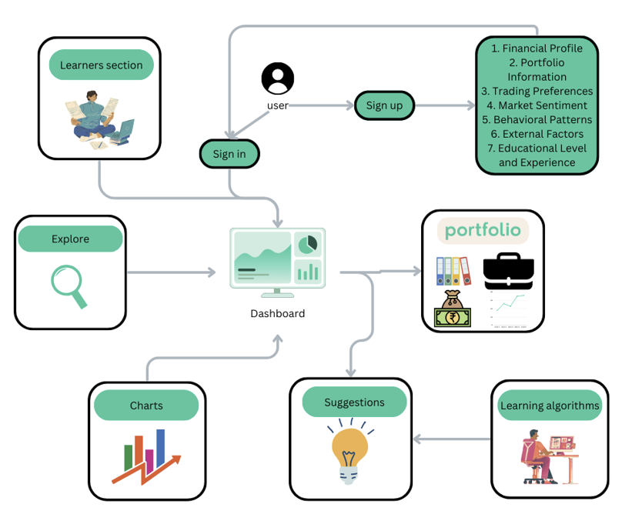

**Fig 4.2 Modular Diagram**

* **User Sign Up/Sign In:**

1. Sign Up: New users register by providing detailed information including:
2. Financial Profile: Their income, assets, liabilities, etc.
3. Portfolio Information: Details of existing investments.
4. Trading Preferences: Their investment strategies and risk tolerance.
5. Market Sentiment: Their outlook on market trends.
6. Behavioral Patterns: Their past trading behaviors and habits.
7. External Factors: Influences like economic indicators.
8. Educational Level and Experience: Their financial knowledge and experience.
9. Sign In: Returning users access their accounts.

* **Dashboard:**

The user accesses a central hub that provides an overview of their financial data and portfolio status. This includes summaries of their assets, recent transactions, and alerts for significant portfolio changes.

* **Portfolio:**

The user can delve into detailed information about their investments, including individual asset performance, portfolio diversification, and overall financial health.

* **Suggestions:**

Based on the user's data, the system generates personalized investment suggestions. These suggestions are derived from the analysis performed by the learning algorithms.

* **Learning Algorithms:**

These algorithms continuously analyze the user’s financial data, market trends, and other factors to provide tailored insights and investment recommendations. They learn from the user’s behavior to refine future suggestions.

* **Charts:**

Users can view various charts that visualize their financial data. This could include performance graphs, trend analyses, and comparative charts that make understanding complex financial information easier.

* **Explore:**

This section allows users to search for additional resources, tools, and information that can aid in their financial decision-making. It might include market news, research reports, and financial calculators.

* **Learners Section:**

This educational module provides users with access to financial learning materials. It helps users improve their financial literacy and make informed investment decisions, offering articles, tutorials, and interactive courses.

This modular system provides a comprehensive approach to managing and understanding one’s financial portfolio, blending personalized insights with educational resources to empower users in their investment journeys.

**Flowchart for the proposed system :**

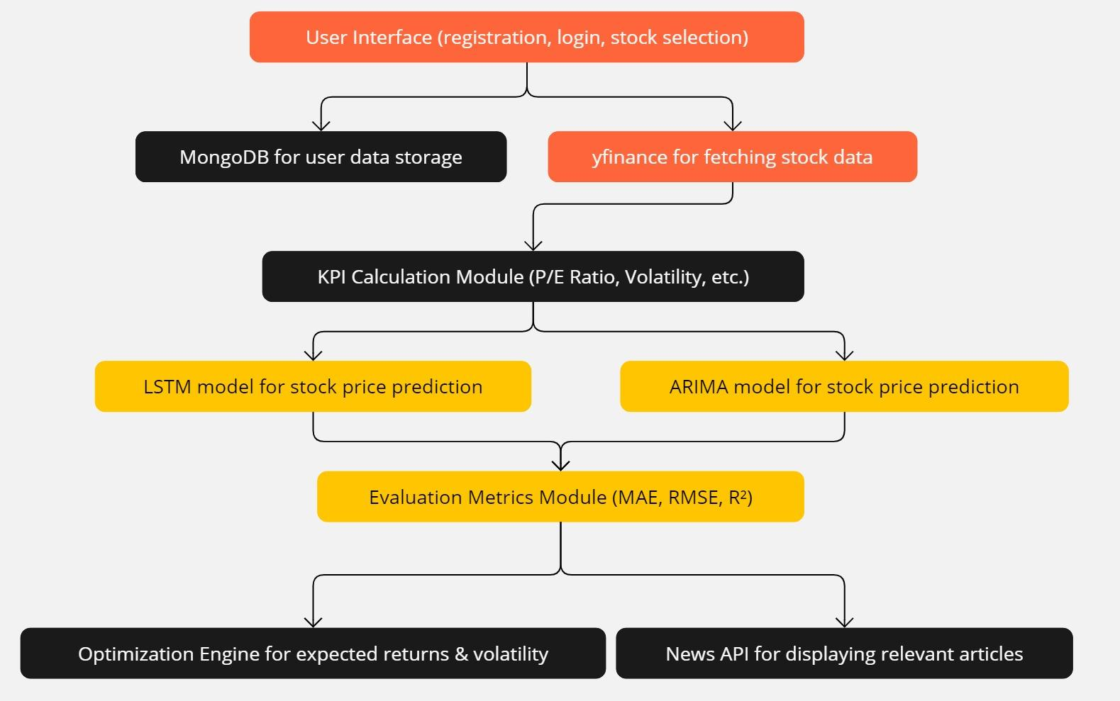

**Fig 4.3 Flowchart**

**4.3. Project Scheduling & Tracking using Time line / Gantt Chart:**

The Gantt chart of our project where we worked for the whole semester to create this model is shown in a timeline pattern. It is the most important part to think and design the planning of your topic and so we planned our work like the gantt chart shown.

| **Phase** | **Tasks** | **Start Date** | **End Date** |
| --- | --- | --- | --- |
| Phase 1: Literature Review | Research, Requirement Gathering, Algorithm Study | July 18, 2024 | July 31, 2024 |
| Phase 2: App Design | App Architecture, Database Setup, APIs Integration | August 1, 2024 | August 14, 2024 |
| Phase 3: Algorithm Development | Develop ARIMA, LSTM Models, Portfolio Optimization | August 15, 2024 | September 7, 2024 |
| Phase 4: App Development | Personalization Features | September 8, 2024 | September 21, 2024 |
| Phase 5: Testing & Evaluation | System Testing, Sensitivity Analysis, Graphs | September 22, 2024 | October 5, 2024 |
| Phase 6: Final Refinement | Refinements, Documentation, Final Report | October 6, 2024 | October 21, 2024 |
| Phase 7: Sentiment Analysis Integration | News Sentiment Analysis | October 22,2024 | November 15,2024 |
| Phase 8: Research Paper Drafting and Submission. | Research paper | November 16,2024 | January 10,2025 |
| Phase 9: Post-Submission Enhancements and Maintenance. | Minor fixes | January 11, 2025 | February 21,2025 |

**Table 1 Schedule**

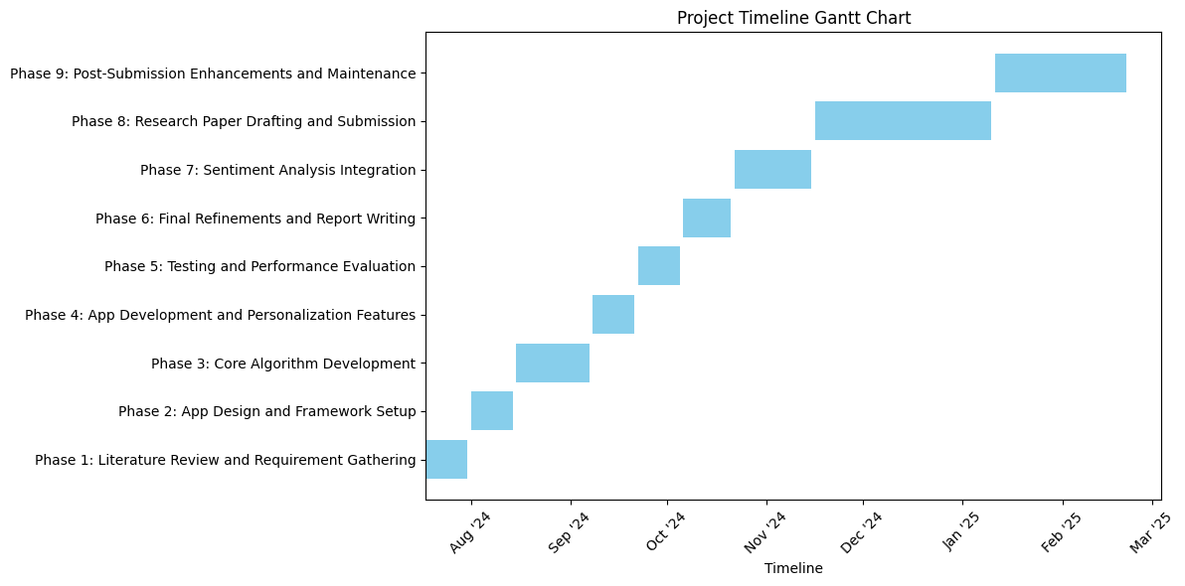

**Fig 4.4 Gantt Chart**

**Chapter 5: Implementation of the Proposed System**

**5.1.Methodology employed for development:**

The development of this project followed a systematic and modular methodology to ensure accuracy and efficiency. Initially, comprehensive data collection was performed by connecting to financial APIs to retrieve historical stock prices for selected companies. The collected data was then preprocessed, handling missing values and normalizing inputs to maintain data quality. Feature engineering was applied to compute key financial metrics such as returns, volatility, and correlation matrices. Subsequently, optimization models like Mean-Variance Optimization were employed, defining objective functions to maximize the Sharpe ratio or minimize portfolio risk under practical constraints. For solving the optimization problem, numerical techniques and libraries (such as SciPy’s optimization tools or machine learning approaches) were utilized. Finally, the results were visualized through graphs like efficient frontiers and allocation charts, helping users intuitively understand the optimized portfolio structure. Each module was developed independently, tested thoroughly, and integrated to create a smooth end-to-end solution.

**5.2.Algorithms and Flowcharts for the respective modules developed:**

We have mainly used two algorithms and 1 for our project:

1. **LSTM Algorithm (Long Short-Term Memory):** LSTM is a type of recurrent neural network (RNN) specifically designed to learn and model sequential data with long-term dependencies. Unlike traditional RNNs, which suffer from vanishing or exploding gradients during training, LSTMs use a unique architecture composed of memory cells and gating mechanisms (input, forget, and output gates) to control the flow of information. This allows them to retain relevant information over extended time intervals and forget irrelevant data, making them ideal for tasks such as time series forecasting, natural language processing, and speech recognition. In stock market prediction, LSTMs are particularly useful because they can capture temporal dependencies and patterns in price movements, enabling more accurate forecasting based on historical data.

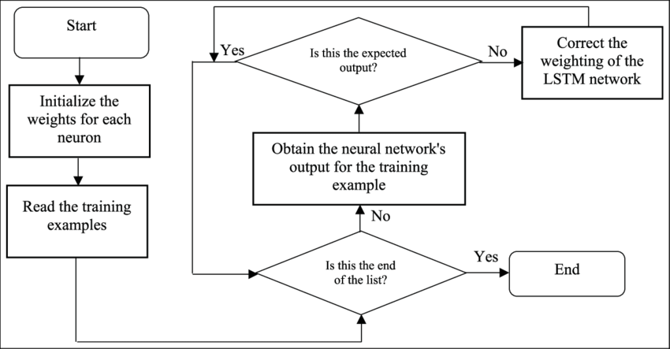

**Fig 5.1 LSTM flowchart**

1. **ARIMA Algorithm (AutoRegressive Integrated Moving Average):** ARIMA is a classical statistical method used for analyzing and forecasting time series data by modeling its own past values and forecast errors. The model is defined by three parameters: (p) for the autoregressive part, which captures the relationship between an observation and a number of lagged observations; (d) for differencing, which makes the time series stationary; and (q) for the moving average part, which models the relationship between an observation and a residual error from a moving average model applied to lagged observations. ARIMA is widely used in financial time series analysis, including stock market forecasting, due to its simplicity, interpretability, and effectiveness in modeling linear patterns and trends.

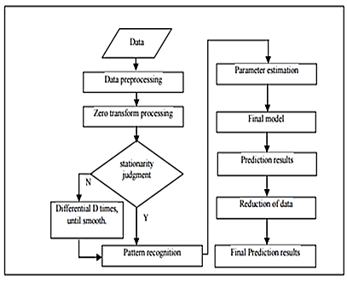

**Fig 5.2 ARIMA flowchart**

1. **Modern Portfolio Theory (MPT):**

Modern Portfolio Theory, introduced by Harry Markowitz in the 1950s, is a mathematical framework for constructing investment portfolios to maximize expected return for a given level of risk. The theory emphasizes diversification—allocating investments across various assets to reduce risk—by analyzing the expected returns, variances, and covariances of asset returns. According to MPT, investors can construct an "efficient frontier" of optimal portfolios offering the highest possible return for a given risk level. MPT relies on the assumption that investors are rational and risk-averse, aiming to minimize portfolio volatility. It remains foundational in portfolio management and asset allocation strategies across global financial markets.

**5.3.Datasets source and utilisation:**

In this project, multiple datasets have been integrated to enable robust portfolio optimization, risk assessment, and stock price prediction. The primary source of historical and real-time stock market data is the **yFinance API**, which provides access to daily stock prices including Open, High, Low, Close, and Volume, along with detailed financial metrics such as the Price-to-Earnings (P/E) ratio, Dividend Yield, and company balance sheet items like Total Liabilities and Stockholder Equity. This data is essential for time-series forecasting using machine learning models like LSTM and ARIMA, where the 'Close' price is used to predict future stock trends. Additionally, it is utilized in the calculation of key performance indicators (KPIs) and to compute daily returns and volatility for the Modern Portfolio Theory (MPT)-based optimization module.

To support sentiment analysis and provide users with up-to-date market context, the project integrates the **NewsAPI**, which fetches real-time news articles based on the names of selected companies. This feature helps investors stay informed about events that may influence stock prices, including earnings reports, economic shifts, or geopolitical developments.

The third dataset source is a **CSV file named ‘All_Indian_Stocks_listed_in_nifty500.csv’**, which contains a comprehensive list of Indian stock tickers and their corresponding company names. This static dataset is used for populating dropdowns in the user interface, enabling users to easily select stocks from a predefined list of NSE-listed companies.

**Chapter 6: Results and Discussions**

**6.1.Screenshot of Use Interface(UI) for the system:**

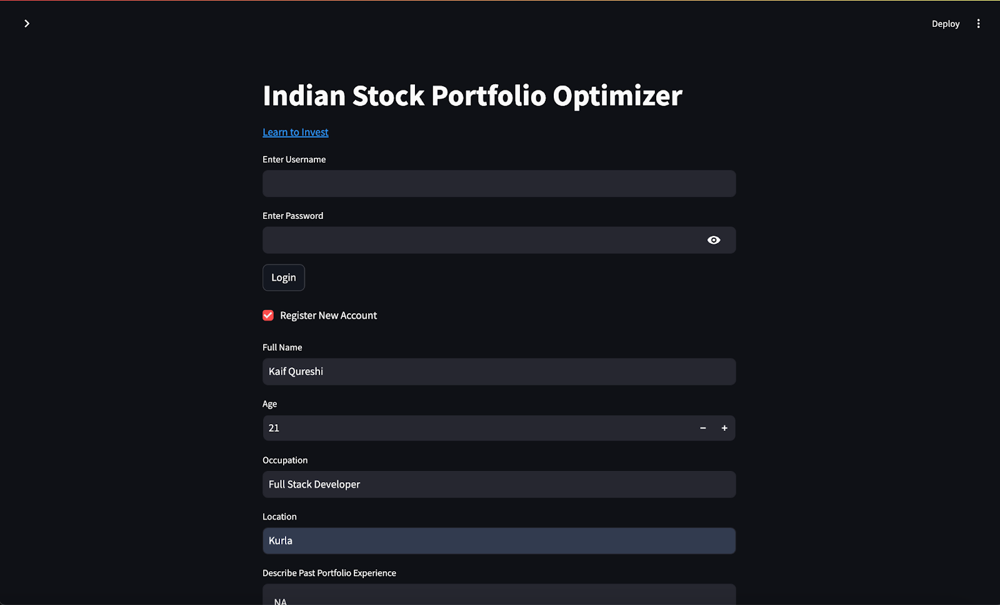

**Fig 6.1 Registration (1)**

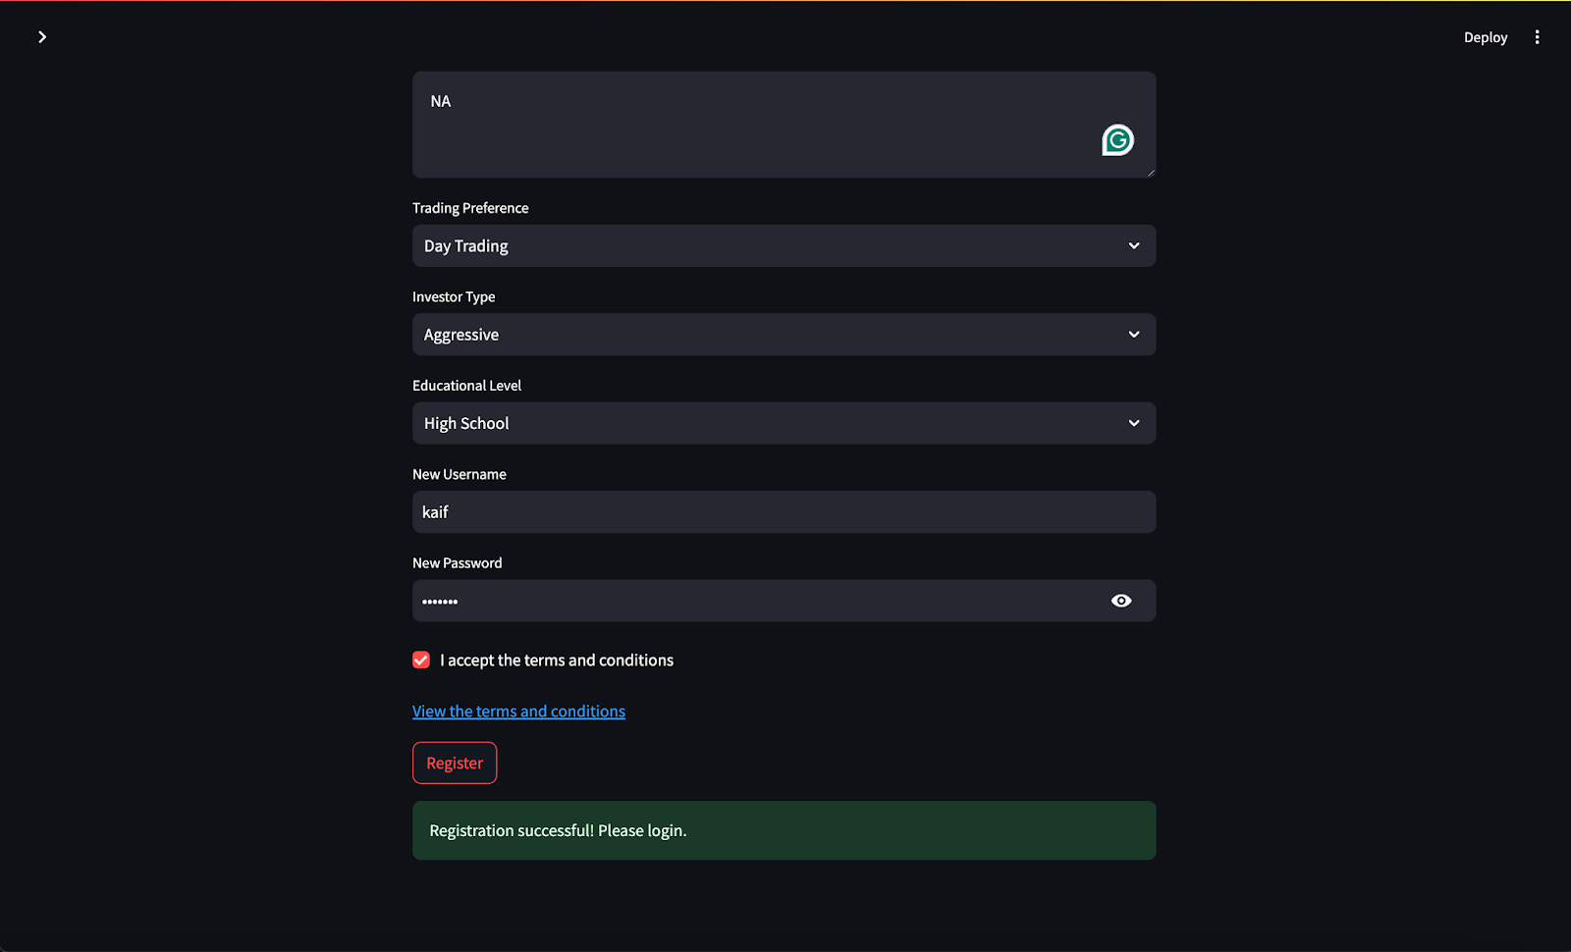

**Fig 6.2 Registration (2)**

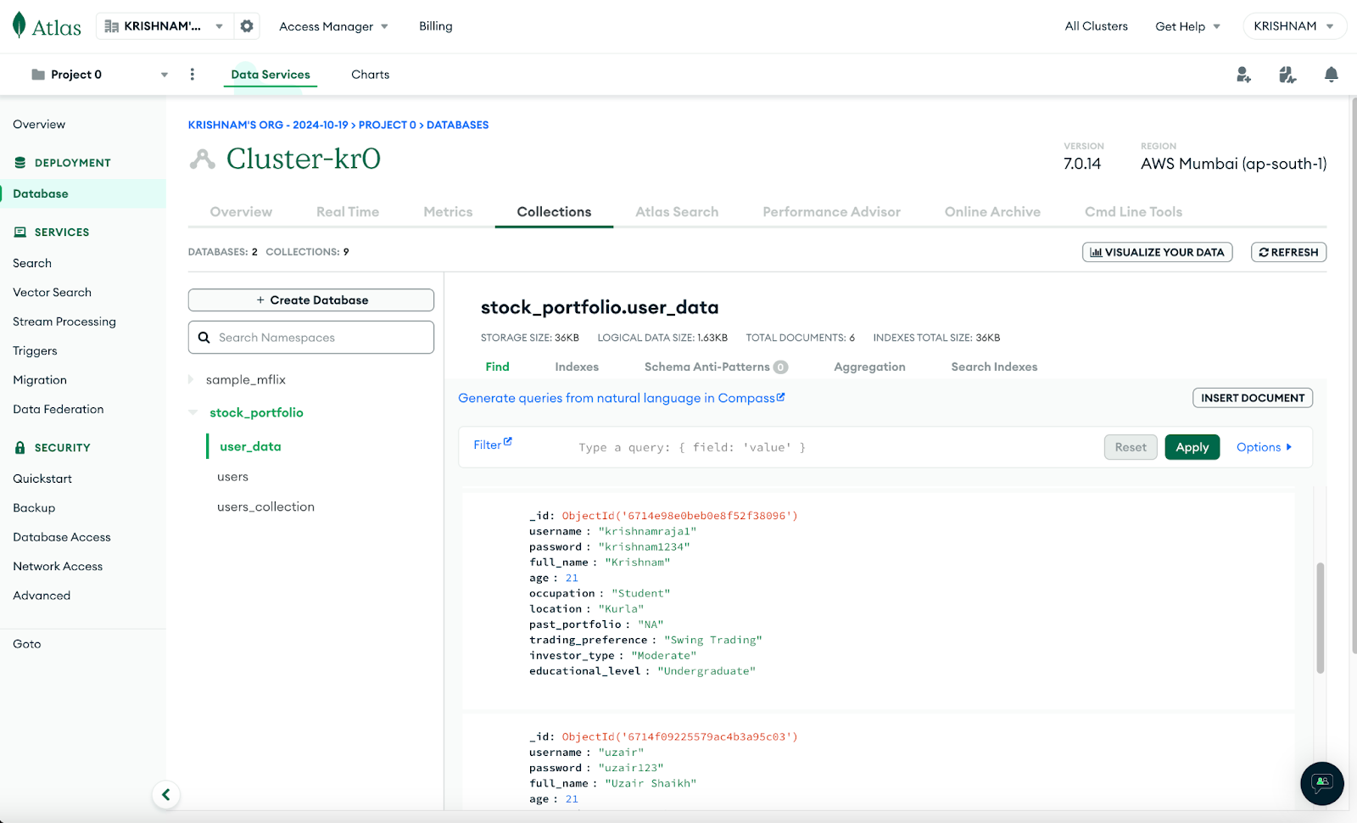

**Fig 6.3 MongoDB Database**

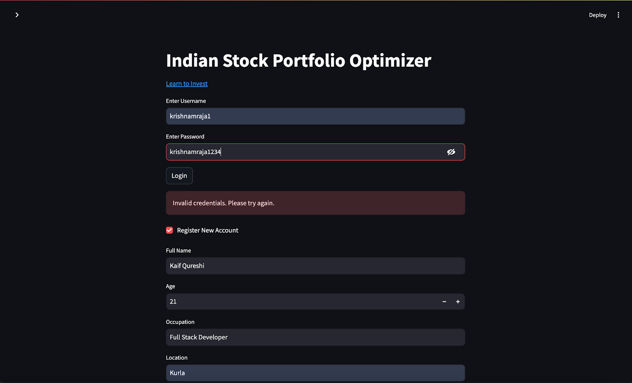

**Fig 6.4 Invalid user Sign in**

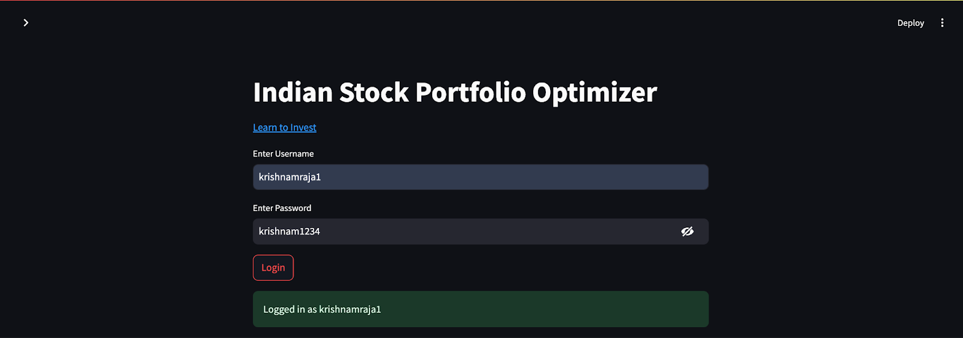

**Fig 6.5 Valid user Sign in**

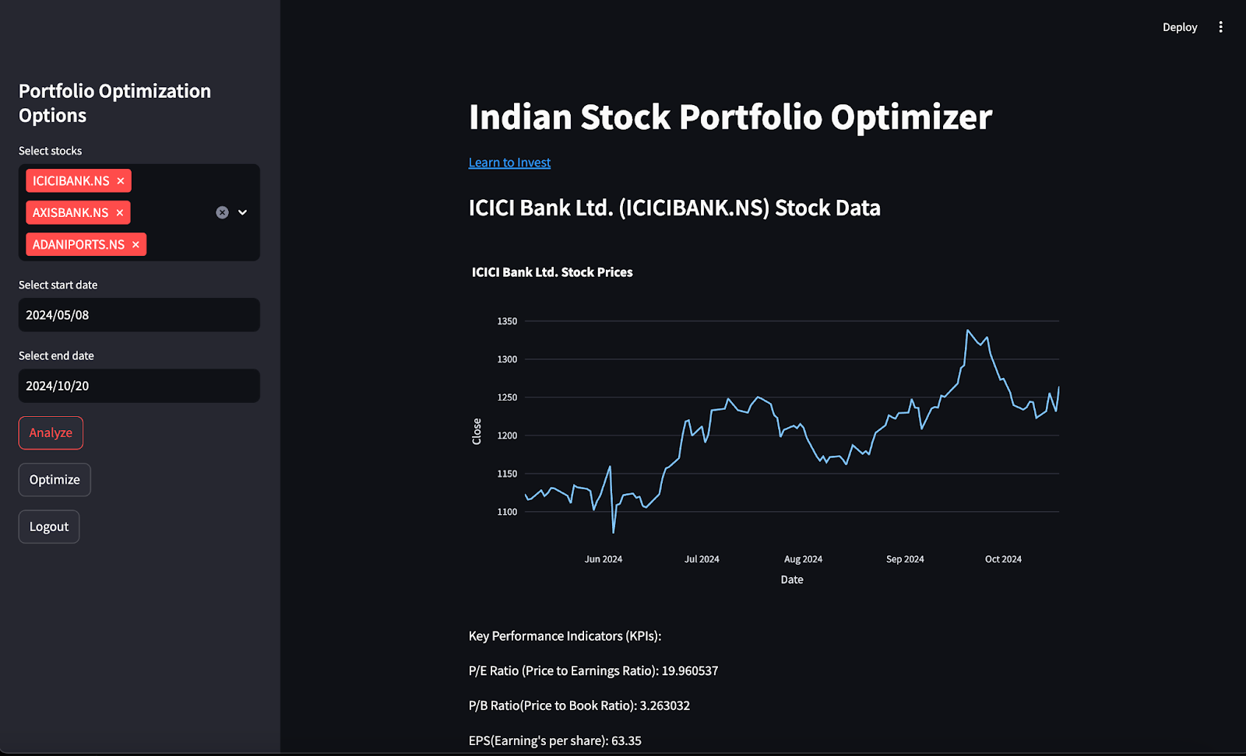

**Fig 6.6 User Dashboard**

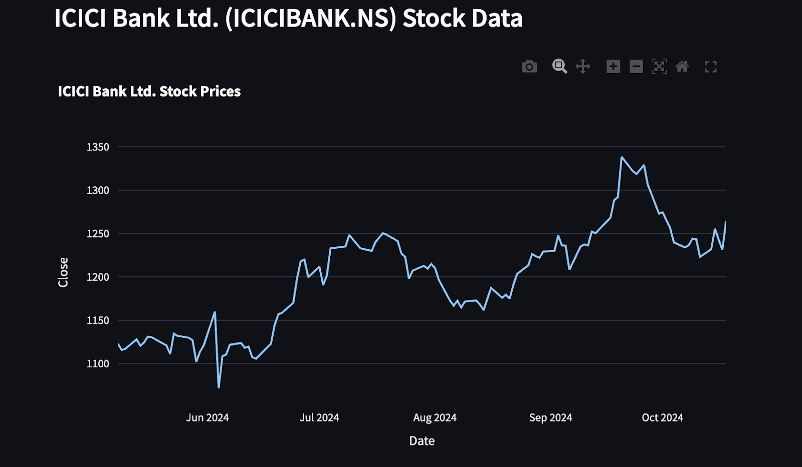

**Fig 6.7 Graph of selected stock (ICICI Bank)**

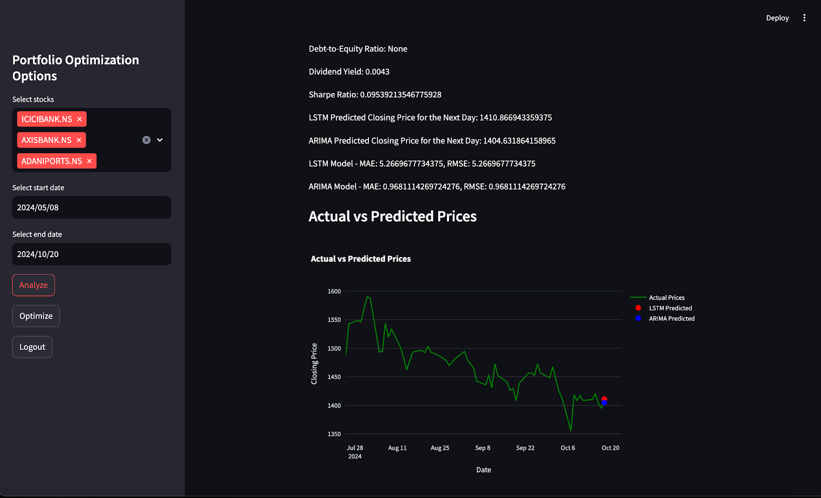

**Fig 6.8 Predictions**

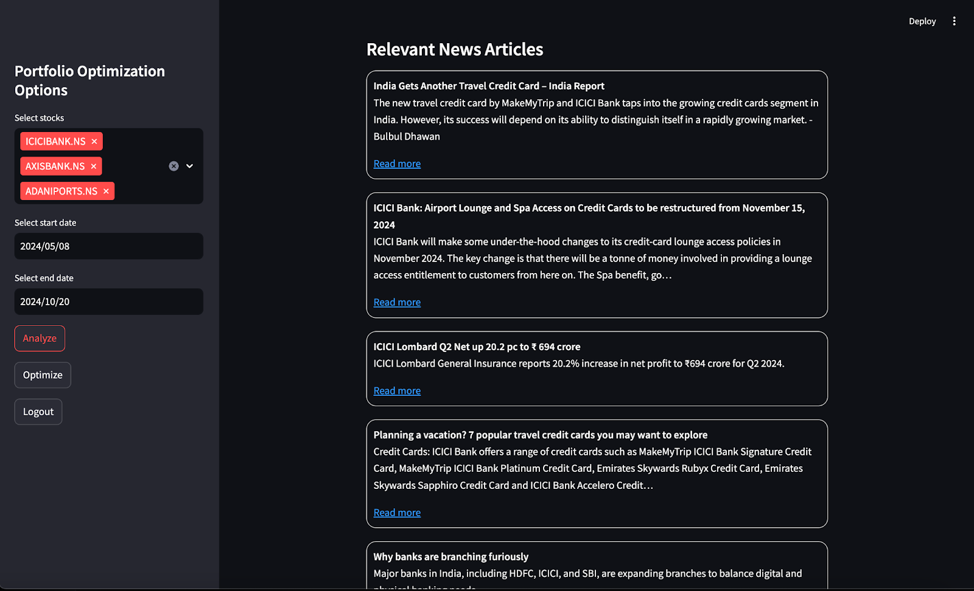

**Fig 6.9 Latest news of selected stock**



**Fig 6.10 News Article**

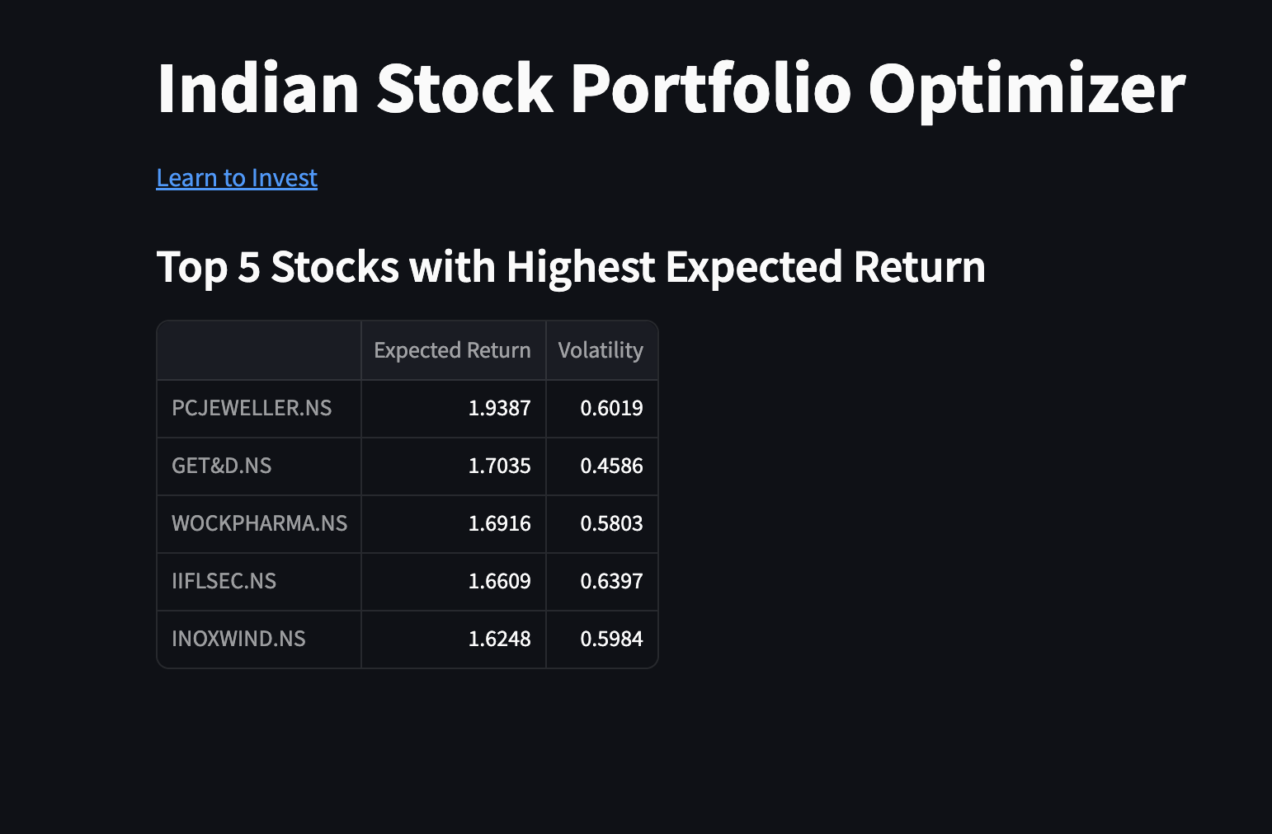

**Fig 6.11 Suggestions**

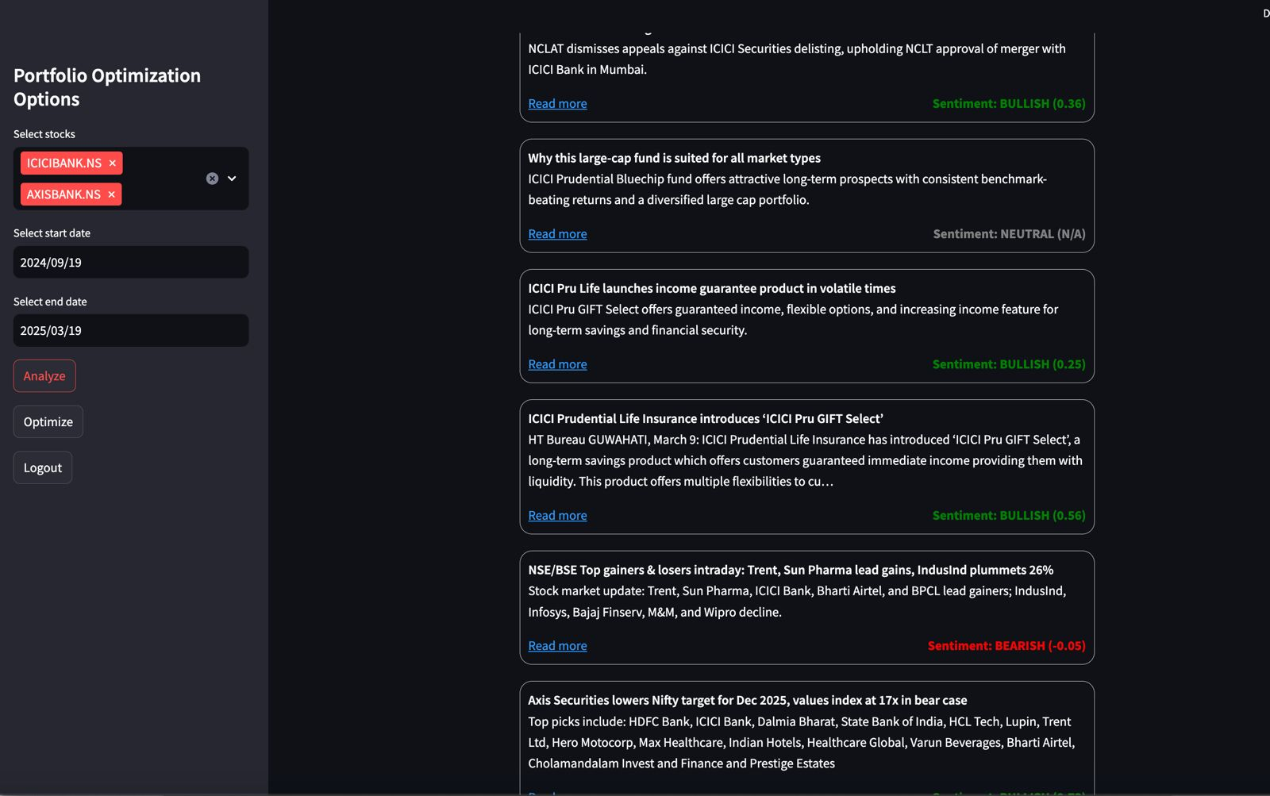

**Fig 6.12 Sentiment Score**

**6.2. Performance Evaluation Measures:**

To evaluate the performance and reliability of the predictive models implemented in this project, multiple statistical evaluation metrics have been employed. The primary parameters include **Mean Absolute Error (MAE)**, **Root Mean Squared Error (RMSE)**, and the **R-squared score (R²)**.

* **MAE** measures the average magnitude of the errors between the predicted and actual stock prices, providing a straightforward indicator of prediction accuracy.
* **RMSE** is used to penalize larger errors more heavily, thereby offering a more sensitive measure of prediction accuracy compared to MAE.
* **R² Score** evaluates the proportion of variance in the actual stock prices that is predictable from the model, offering insight into the model’s overall fit.

Additionally, for portfolio evaluation, financial performance indicators such as **expected return**, **volatility**, and **Sharpe Ratio** are used. The Sharpe Ratio helps in assessing the risk-adjusted return of a portfolio, while expected return and volatility are key parameters in the implementation of **Modern Portfolio Theory (MPT)**.

For real-world relevance, the system also displays **visual comparisons** between actual and predicted prices through interactive graphs, allowing for intuitive evaluation. These parameters collectively help ensure that the stock prediction models and portfolio suggestions are both **statistically sound and practically useful**.

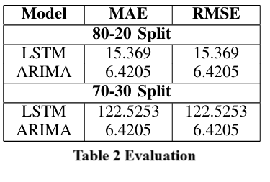

**6.3. Comparison of Results with Existing System:**

| **Feature** | **Existing Systems** | **Proposed System (Your Project)** |
| --- | --- | --- |
| **Stock Price Prediction** | Limited or basic predictive models, often rule-based | Uses advanced ML models: LSTM for long-term trends and ARIMA for short-term |
| **Real-Time Market Data Integration** | Mostly static or delayed data | Integrated real-time data using yFinance API |
| **Risk Assessment** | Basic risk scores or generic volatility measures | Detailed KPIs and risk metrics like Volatility, Debt-to-Equity, Sharpe Ratio |
| **Portfolio Optimization** | Generic, one-size-fits-all allocation | Custom optimization using Modern Portfolio Theory (MPT) |
| **User Personalization** | Minimal to no personalization | Personalized portfolios based on risk tolerance, experience, and preferences |
| **Financial News Integration** | Often absent or limited to ticker feeds | Uses NewsAPI to fetch and display relevant, real-time news articles |
| **User Interface** | Complex dashboards, not beginner-friendly | Intuitive, interactive UI built with Streamlit |
| **Data Storage** | Local or basic cloud storage | Secure cloud-based MongoDB database for storing user data and preferences |
| **Educational Content** | Rarely available | Includes "Learn to Invest" module for financial literacy |
| **Model Evaluation & Transparency** | Limited model evaluation, no error metrics | Includes MAE, RMSE, R², and visual graphs for model performance |

**Table 3 Comparison of results**

**6.4. Inference Drawn:**

The comparison clearly highlights that the proposed system significantly enhances traditional portfolio optimization platforms by integrating advanced machine learning models like LSTM and ARIMA for more accurate stock predictions, real-time data feeds through APIs, and personalized investment strategies based on user profiles. Unlike existing systems that often offer generic recommendations and limited analytics, this project introduces robust risk assessment metrics, dynamic portfolio optimization using Modern Portfolio Theory, and financial news integration for better market awareness. Additionally, the user-friendly interface, educational support, and transparent model evaluation make the system more accessible, insightful, and adaptable for both novice and experienced investors.

**Chapter 7: Conclusion**

**7.1.Limitations:**

Despite offering several advanced features and enhancements over traditional systems, the proposed portfolio optimization framework has certain limitations which are outlined below:

* **API Dependency**: The system heavily relies on third-party APIs such as yFinance and NewsAPI for fetching real-time stock data and financial news. Any changes in API availability, rate limits, or data structure may adversely affect the system's performance and functionality.
* **Computational Overhead**: Machine learning models like LSTM require substantial computational resources and time for training, particularly when dealing with large datasets or extended time periods. This may affect the scalability and responsiveness of the application in real-time scenarios.
* **Model Assumptions and Constraints**: The ARIMA model assumes linearity and stationarity in the data, which may not accurately reflect real-world market dynamics. Similarly, LSTM models, while powerful, are sensitive to hyperparameter tuning and require careful preprocessing for optimal performance.
* **Limited Asset Coverage**: The current implementation is limited to Indian equity stocks. It does not support other asset classes such as mutual funds, systematic investment plans (SIPs), bonds, or international financial instruments.
* **Prediction Limitations**: While the system employs sophisticated algorithms for price prediction, stock market behavior remains inherently unpredictable due to various external and unforeseen factors. Therefore, absolute accuracy in predictions cannot be guaranteed.
* **Partial Risk Modeling**: The platform primarily uses historical data to assess volatility and calculate key performance indicators. It does not yet incorporate macroeconomic indicators, geopolitical risks, or deep sentiment analysis, which can significantly impact market performance.
* **Basic User Profiling**: Although the system considers user preferences such as risk tolerance and investment goals, it lacks comprehensive financial profiling, including income levels, tax planning, and long-term financial objectives.
* **Security Considerations**: Current user authentication mechanisms are basic. The system would benefit from enhanced security features such as encrypted password storage, two-factor authentication, and secure API key management to ensure robust protection of user data.

**7.2.Conclusion:**

This project presents a comprehensive and innovative approach to modern investment management. By leveraging machine learning algorithms such as LSTM and ARIMA, along with Modern Portfolio Theory (MPT), the system is capable of predicting stock price movements and optimizing portfolios based on expected return and associated risk. The integration of real-time stock data through yFinance and relevant financial news via NewsAPI ensures that the platform remains dynamic and adaptable to changing market conditions. The inclusion of key performance indicators (KPIs) further enhances decision-making by providing investors with deeper financial insights into individual stocks.

Additionally, the project addresses some of the major limitations found in existing systems by offering a user-friendly interface, personalized investment recommendations, and educational resources to promote financial literacy. While the system currently focuses on Indian equities and has certain limitations in terms of scalability, asset diversification, and advanced risk modeling, it lays a solid foundation for future enhancements. With further development, including the incorporation of mutual funds, SIPs, and deeper financial profiling, this project has the potential to evolve into a full-fledged intelligent investment advisor platform that can cater to a wide range of investors, from beginners to professionals.

**7.3.Future Scope:**

**Incorporation of Additional Asset Classes**: Extend the platform to include support for mutual funds, Systematic Investment Plans (SIPs), exchange-traded funds (ETFs), and bonds to provide a more diversified investment portfolio.  
**Enhanced Financial Profiling**: Implement advanced user profiling features by capturing data related to income, expenses, risk capacity, investment horizon, and financial goals for more accurate and tailored recommendations.  
**Integration of Macroeconomic Indicators**: Include macroeconomic variables such as GDP growth, inflation rates, and interest rates to improve the accuracy of predictions and risk assessment models.  
**Advanced Risk Modeling Techniques**: Incorporate models like Value at Risk (VaR), Conditional VaR, and Monte Carlo simulations to provide a more comprehensive analysis of potential portfolio risks.  
**Sentiment Analysis and Social Media Trends**: Leverage Natural Language Processing (NLP) to analyze financial sentiment from news articles, social media platforms, and analyst reports to enhance market trend prediction.  
**Mobile Application Development**: Develop a cross-platform mobile application to increase accessibility and allow users to monitor and manage their investments on the go.  
**Implementation of Two-Factor Authentication (2FA)**: Enhance platform security by integrating 2FA and encrypted password storage to protect sensitive user data and account access.  
**Real-time Portfolio Rebalancing**: Introduce automated portfolio rebalancing strategies that adjust asset allocations in response to market changes and evolving user preferences.  
**Scalability through Cloud Infrastructure**: Migrate core components to cloud platforms (e.g., AWS, Azure) to support large-scale usage and ensure system reliability under high load conditions.

**References**

[1] [Marin Lolic, “Practical Improvements to Mean-Variance Optimization for Multi-Asset Class Portfolios”, J. Risk Financial Manag. 2024, 17(5), 183.](https://www.mdpi.com/1911-8074/17/5/183)

[2] [Yu Ma, Rui Mao, Qika Lin, Peng Wu, Erik Cambria, “Quantitative stock portfolio optimization by multi-task learning risk and return”, Information Fusion Volume 104, April 2024, 102165](https://www.sciencedirect.com/science/article/abs/pii/S1566253523004815?via%3Dihub)

[3] [Preeti Paranjape-Voditel, Umesh Deshpande, A stock market portfolio recommender system based on association rule mining, Applied Soft Computing, Volume 13, Issue 2, 2013](https://www.sciencedirect.com/science/article/abs/pii/S1568494612004322?via%3Dihub)

[4] [Jie Zou, Jiashu Lou, Baohua Wang, Sixue Liu, A novel Deep Reinforcement Learning based automated stock trading system using cascaded LSTM networks, Expert Systems with Applications, Volume 242, 2024](https://www.sciencedirect.com/science/article/abs/pii/S0957417423033031?via%3Dihub)

[5] [Zaharaddeen Karami Lawal; Hayati Yassin; Rufai Yusuf Zakari”Stock Market Prediction using Supervised Machine Learning Techniques: An Overview”2020 IEEE Asia-Pacific Conference on Computer Science and Data Engineering (CSDE), 2020](https://sci-hub.se/https://ieeexplore.ieee.org/document/9411609)

[6] [AmirMohammad Larni-Fooeik,Seyed Jafar Sadjadi,Emran Mohammadi , “Stochastic portfolio optimization: A regret-based approach on volatility risk measures: An empirical evidence from The New York stock market”, April 22, 2024](https://journals.plos.org/plosone/article?id=10.1371/journal.pone.0299699)

[7] [David Ajiga, Rhoda adura Adeleye, Tula Sunday Tubokirifuruar, Binaebi Bello, Onyeka, Franca Asuzu, Oluwaseyi Rita Owolabi, ” MACHINE LEARNING FOR STOCK MARKET FORECASTING: A REVIEW OF MODELS AND ACCURACY”, Finance &amp; Accounting Research Journal, Volume 6, Issue 2, February 2024](https://www.researchgate.net/publication/380289212_MACHINE_LEARNING_FOR_STOCK_MARKET_FORECASTING_A_REVIEW_OF_MODELS_AND_ACCURACY)

[8] [Research on Optimization Strategy of Quantitative Investment Scheme Based on Black-Litterman Model Jinhui Zhang* , Lanlan Shi, Wei Xu](https://francis-press.com/uploads/papers/3sFXSwHmglRb1BhSQ5ObXItQuFXhQPairPdApWOQ.pdf)

[9] [N. . Pai, I. . V., and N. . B., “An Optimal Portfolio Construction for Asset Management with Back-Test Using PSO Algorithm and PyPortfolioOpt in Indian Stock Market”, Int J Intell Syst Appl Eng, vol. 12, no. 2s, pp. 352 –, Oct. 2023](https://ijisae.org/index.php/IJISAE/article/view/3634)

[10] [Sen, J., Dasgupta, A., Sengupta, P. P., & Choudhury, S. R. (2023). A Comparative Study of Portfolio Optimization Methods for the Indian Stock Market. ArXiv. /abs/2310.14748](https://arxiv.org/pdf/2310.14748)

**Appendix**

**1] Paper I details :-**

**a.Paper I :-**

**Abstract**

Stock market allocation optimization is a key component of financial research that seeks to maximize profits while minimizing risk. This study describes a novel approach to portfolio optimization that employs the LSTM model, the ARIMA model, and Modern Portfolio Theory (MPT). The methodology involves preprocessing historical stock data, trend prediction with the ARIMA model, portfolio allocation with MPT, and dynamic optimization with LSTM to improve predictive skills. The dataset includes a broad selection of equities from several time periods, allowing for rigorous examination. The major findings emphasize the system’s improved accuracy in stock prediction and risk management, demonstrating the possibility for integrating machine learning models with conventional finance ideas.This investigation contributes to the continued development of portfolio management strategies and demonstrates the efficacy of blended AI-driven methodologies in the financial sector. Index Terms—Portfolio Optimization, LSTM, ARIMA, Modern Portfolio Theory, Machine Learning, Stock Prediction, Financial Models

**b.Plagiarism Report**

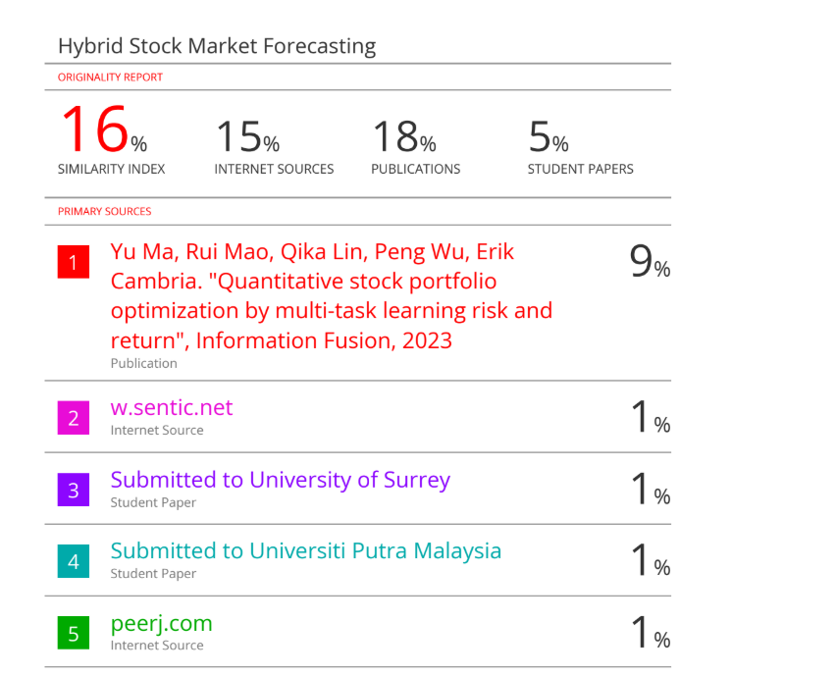**c.Project review sheet**

**Project review sheet 1:**



**Project review sheet 2 :**



**2] Competition Certificates :-**



